Real-Life Examples of Opportunity Cost

<https://www.stlouisfed.org/>

What do economists think about strawberry smoothies? That depends on how good the kiwi flavor is instead—plus a range of other choices. Which stirs up the idea of opportunity cost.

How is opportunity cost defined in everyday life?

“Opportunity cost is the value of the next-best alternative when a decision is made; it's what is given up,” explains Andrea Caceres-Santamaria, senior economic education specialist at the St. Louis Fed, in a recent Page One Economics: [Money and Missed Opportunities](https://research.stlouisfed.org/publications/page1-econ/2019/10/01/money-and-missed-opportunities).

## The Scoop on Scarcity

We can’t have everything we want in life. This is where scarcity factors in. Our unlimited wants are confronted by a limited supply of goods, services, time, money and opportunities. This concept is what drives choices—and, by extension, costs and trade-offs, Caceres-Santamaria says.

She uses the example of deciding to buy a $7 smoothie at the mall. She notes that many people would view the choice as a single one based on whether you want the drink.

Instead, she suggests wearing “a unique pair of ‘economist glasses’” to see the decision differently, asking:

1. How much do I value this?
2. What am I giving up now to have this?
3. What am I giving up in the future to have this now?

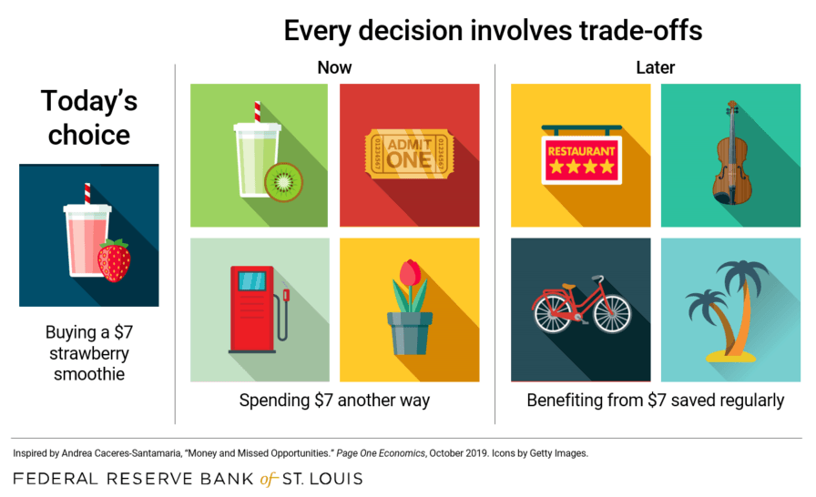

## Costs That Are Seen and Unseen

Our inclination is to focus on immediate financial trade-offs, but trade-offs can involve other areas of personal or professional well-being as well—in the short and long run.

That’s why Caceres-Santamaria challenges us to consider not only **explicit alternatives**—the choices and costs present at the time of decision-making—but also **implicit alternatives**, which are “unseen” opportunity costs.

“It's about thinking beyond the present and assessing alternative uses for the money—that is, not being shortsighted,” she writes.

What are some other examples of opportunity cost?

* A student spends three hours and $20 at the movies the night before an exam. The opportunity cost is time spent studying and that money to spend on something else.
* A farmer chooses to plant wheat; the opportunity cost is planting a different crop, or an alternate use of the resources (land and farm equipment).
* A commuter takes the train to work instead of driving. It takes 70 minutes on the train, while driving takes 40 minutes. The opportunity cost is half an hour spent elsewhere each day.

## Is Opportunity Cost a Big Deal?

We might not consider lost studying time or $7 spent on a smoothie costly decisions, but what about bigger choices—like the decision to stretch and buy a more expensive home versus a starter home, or to spend $1,500 more on an upgraded trim package for your next car?

Caceres-Santamaria describes how opportunity costs are neglected even more when making higher priced purchases. Using the car-buying example, a consumer might default to thinking of the **relative value** of the $1,500 upgrade to the base price of the car, say, $18,500.

Rather than comparing the fancier configuration to the vehicle itself, it might be more helpful to ask what else that $1,500 could buy outright.